**Order Support** (<https://magento.abmgood.com/support/index/Suporder/>):

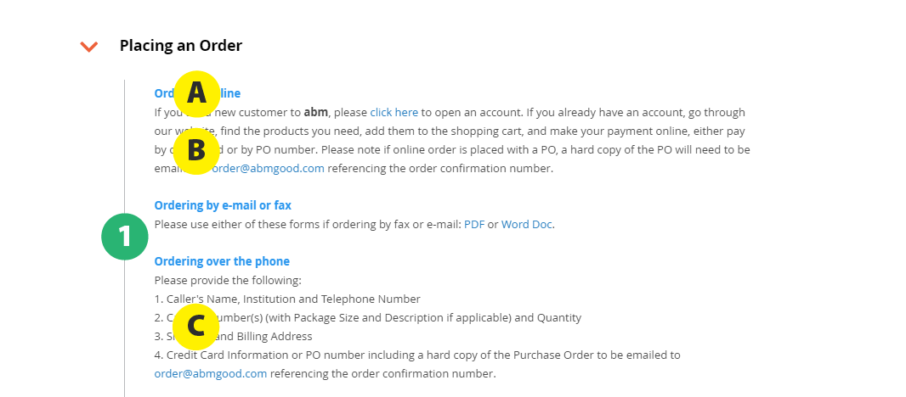

**Careers - Stories Page** (<https://magento.abmgood.com/careers/index/stories>)

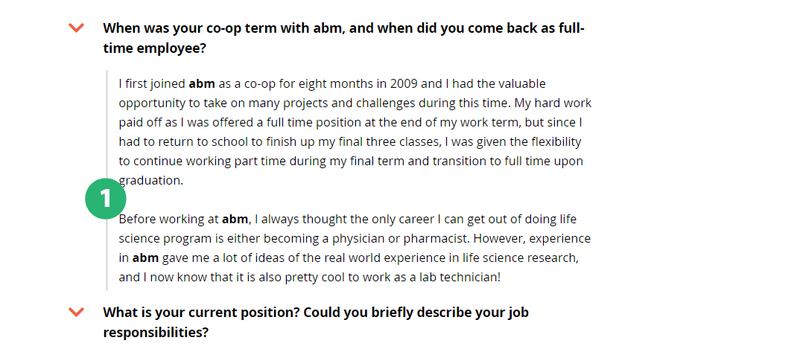

Notes:

* **1:** Match the amount of spacing between the vertical line and the text
* **A: Blue headings**
  + Change blue headings to black (color: #000)
* **B: Blue links in the FAQ paragraphs**
  + Change blue links to orange
  + color: #ef6331 (keep current hover colour)
* **C: Numbered lists**
  + Can you make the numbered lists actual lists (<ol>)

Make the following text style…

FAQs:

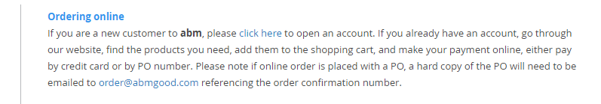

PDF files:

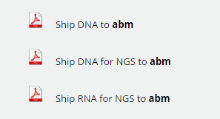

Contact info:



… have the same **font size** and **line height** as the regular paragraph style on the page:

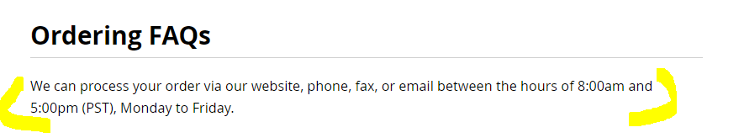

*More notes on the next page.*

**Breadcrumb:  
**

* Make “Home” and “Resources & Support”:
  + match font size as “Order Support”
  + color: #808083
* Vertically align the text and the arrows > (right now, looks like the arrows are floating higher)

**PDF files:**



* Vertically align the PDF image to the text

**Contact info:**

**

* Change blue links to orange
  + color: #ef6331 (keep current hover colour)
* Make all telephone numbers links (currently, only the toll free number is clickable)
* Move the hours to the heading for Live Chat and Telephone:
  + Eg. **Live Chat - 8:00am to 5:00pm PST (Mon-Fri)**
* Can the icons be bigger?
  + Eg. closer to this size ratio:



* Also, can we use these icons instead:
  + Email: <https://fontawesome.com/v4.7.0/icon/envelope-o>
  + Live Chat: <https://fontawesome.com/v4.7.0/icon/comments-o>
  + Telephone: <https://fontawesome.com/v4.7.0/icon/phone>

**Spacing between a new section and the header:  
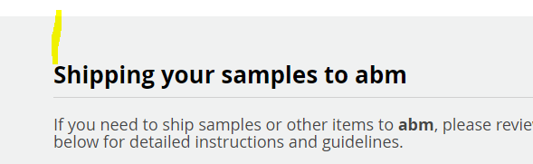 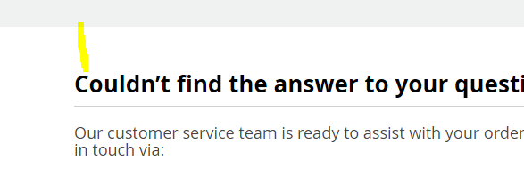**

* + Currently: <div class="OrderSupportDiv" style=" padding-top: 50px;">
  + Can we increase this to padding-top: 80px to match the spacing between where the grey area starts and the heading “**We’re committed to excellent customer service”** on the Resources and Support page: <https://magento.abmgood.com/support/index/index/>